**Name: ______________________ Class: __________________**

**AU4: HW #1 – Graphing Systems Date: __________________**

**Graph the two linear equations and find the solution.**

**1.**  **2.** 



**3.**  **4.** 



**5.  6. **



**Find the solution to the given systems.**

**7. 8.**

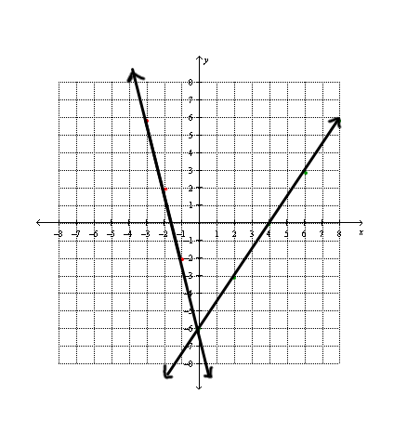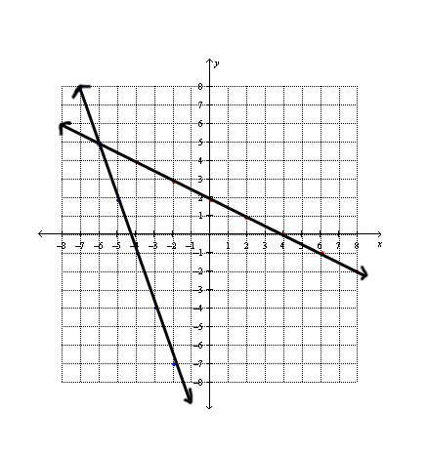

**Spiral – Show all work:**

***Solve the following equations:***

**9.** **10.** 